[Enter Post Title Here]

**HOTEL MANAGEMENT HOSPITAL MANAGEMENT**

**1**.USE CASE **1.**USE CASE

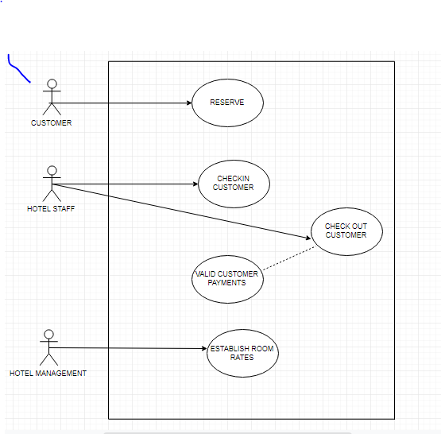 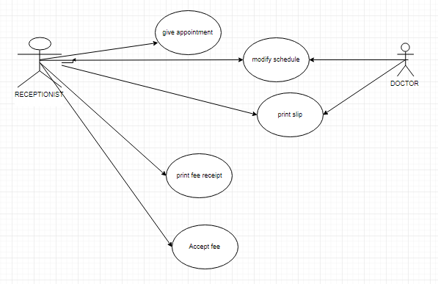

**2**.CLASS **2.**CLASS

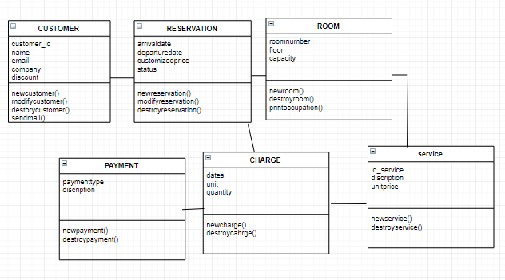 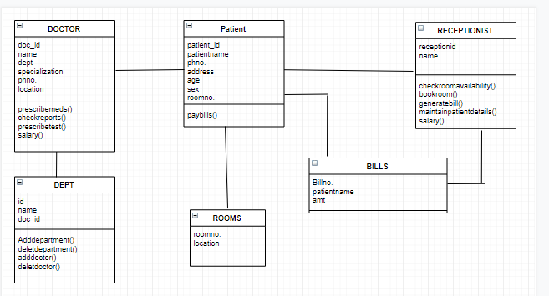

**3**.ER DIAGRAM **3**.ER DIAGRAM

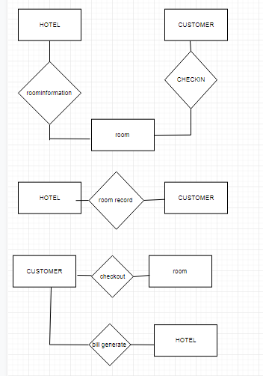 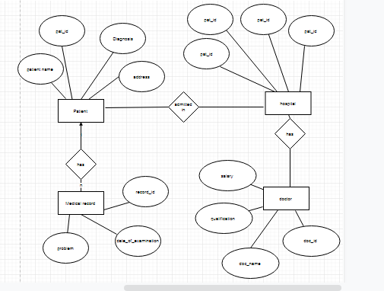

**4.** DFD **4.**DFD

